**MID ASSIGNMENT 02**

**TECHNOPRENEURSHIP HS353**

**SOFTWARE ENGINEERING**

**SECTION A**

**TOTAL MARKS 10**

**INSTRUCTIONS**

* This assignment carries 10 marks.
* The maximum time available for the assignments is 3 weeks.
* First Deadline: All those, who submit assignments by 18th July 2020, will be granted one additional mark.
* Second Deadline: There will be no bonus or penalty, if you submit the assignment after 18th July 2020, but before 25th July 2020.
* Last Deadline: Any assignment submitted after 25th July 2020, but before 27th July 2020, will be liable to a penalty of 50% of the total marks.
* No assignment will be accepted after 27th July 2020 at any cost.
* Type all the answers on a word file and save it as a pdf. Your file name should be same as your Roll No.
* Exam answers will also be checked through Turnitin for originality. Max. Limit for plagiarism is 25%

**CASE STUDY**

NOTE: Read the Case study carefully and answer the application Questions.

**Introduction**

Imagine the following. You’re in the audience of a business plan competition. The next team up to present is d.light, a for-profit social enterprise that plans to bring light to people without access to reliable electricity.

Two young men introduce themselves as the founders of d.light, and say they’re going to start their presentation with a demonstration. The lights go out. In a few seconds, you see a dim light at the front of the room, and smell smoke and burning kerosene. After about 30 seconds, your eyes start to water and it becomes slightly uncomfortable to breathe. The lights switch back on and the smoke clears.

The young men apologize for the lack of light and smoke, but say the demonstration was staged to illustrate a point. Around 1.5 billion people, or more than one fifth of the world’s population, have no access to electricity, and about a billion more have an unreliable or intermittent supply.

A large share of these people use kerosene to light their homes at night. Kerosene fumes are extremely unhealthy, even fatal. In fact, the United Nations estimates that kerosene fumes kill 1.5 million people per year, and cause countless health complications for others.

**Sam Goldman and the Origins of d.light**

The scene described here actually took place—several times. It’s the way **Sam Goldman** and **Ned Tozen**, the cofounders of **d.light**, introduced the company at business plan competitions and when they pitched investors. d.light is an international consumer products company serving “base of the pyramid” consumers who don’t have access to reliable electricity.

Although d.light technically started in a class at Stanford University, its beginning can be traced to Sam Goldman’s youth and early adulthood. Growing up, Goldman’s parents worked for the United States Agency for International Development (USAID), a government agency that provides economic and humanitarian assistance in countries across the globe.

Goldman lived in Pakistan, Peru, India, Canada, and several other countries. As a young adult, while working for the Peace Corps, he lived for four years in a West African village that had no electricity. A neighbor boy was badly burned in a kerosene fire, an event that deeply impacted Goldman. At one point during his time in the village, Goldman was given a battery-powered LED headlamp, and was struck by the dramatic difference that simply having light at night can make in a person’s life. He could now cook, read, and do things at night that were unimaginable without the benefits reliable lighting provides. Impacted by this experience, Goldman sought out a graduate program that would provide him the opportunity to start thinking about creating a business to take light to people without access to reliable electricity.

He landed at Stanford, which was starting a program in social enterprise. A pivotal class was Jim Patelli’s 2006–2007 Entrepreneurial Design course. The class was divided into teams, and each team was challenged to address a significant issue in the developing world.

Goldman was teamed up with Ned Tozen, a business classmate, and two engineering students, Erica Estrade and Xian Wu. The team tackled the problem of light for people without access to reliable electricity, and developed a rough prototype of a portable LED light that could be recharged via solar power. That spring, the team traveled to Burma for the purpose of going into villages that didn’t have access to electricity to introduce their device. Villagers told them they spent up to 40 percent of their income on kerosene.

When shown how their crude prototype could provide light at night and be recharged during the day simply by deploying small solar panels on their homes, the villagers were so taken that one women actually wept. According to one account of the team’s trip, in one village the local police confiscated the prototypes. They, too, needed light at night.

**Design and Distribution**

After completing the Entrepreneurial Design course, the teammates headed their separate directions for the summer. In the fall, they reunited, and determined to continue to work on their business concept. The concept of using solar power to recharge portable lights in poor rural areas wasn’t new. In fact, it had been tried many times. The problem, in Goldman and his team’s estimation, was a combination of design and distribution. Previous models relied either on NGOs and governments “giving” fairly expensive lights to people without access to electricity, which they couldn’t afford to replace when used up or if broken, or commercial enterprises buying extremely inexpensive lights in China and exporting them to Africa and elsewhere, where they performed poorly.

It was clear to Goldman that neither of these models was sustainable. So Goldman and his team, driven by the possibility of changing literally millions of people’s lives throughout the world, recruited talented engineers and distribution experts, who worked on a near pro bono basis, to help with the project.

The goal was to produce a solar-powered portable LED light that was exactly what rural villagers needed—nothing more and nothing less. It also had to be cheap enough that villagers could afford it yet produce sufficient margins for d.light to be profitable. The decision was made early on that d.light would be a for-profit company.

The company’s goal was not to impact 100,000 people or a million people but to impact hundreds of millions of people. Goldman and his team knew that their lofty ambitions would take cash and additional R&D efforts, which would require private-sector investment capital. During this period, which covered the summer of 2007 until early 2008, Goldman and his cofounders continued traveling to remote areas for the purpose of obtaining feedback about their prototype.

During Christmas break, instead of traveling home to see his family, Goldman was in the middle of Miyamairi doing research. The team thinned some in early 2008, with Goldman, Tozan, and Wu continuing. d.light was now up-and-running and opened its first international offices in India, Shenzhen, China, and Tanzania.

**Business Plan Competitions and Investor Presentations**

One thing Goldman stresses during talks about d.light is the instrumental role that the company’s business plan played in helping the company take shape and in raising investment capital. Early on, d.light entered several business plan competitions.

It the spring of 2007, it took second place in the University of California, Berkley’s Social Venture Competition and won first prize at Stanford’s Social E-Challenge. A big breakthrough happened in May 2007 when the team claimed the $250,000 first prize in the prestigious Draper Fisher Jurvetson Venture Challenge competition. This money provided seed funding for much of the work that was completed during the summer and fall of 2007. What’s particularly interesting is Goldman’s reflections on why his company was so successful in business plan competitions and eventually investor presentations— reflections that are instructive for all young businesses. There are six reasons, shown in the table that follows. Collectively, these attributes presented d.light as an organization with a compelling idea, a strong team, large markets, a product focus and a coherent, resolute, and extremely admirable vision 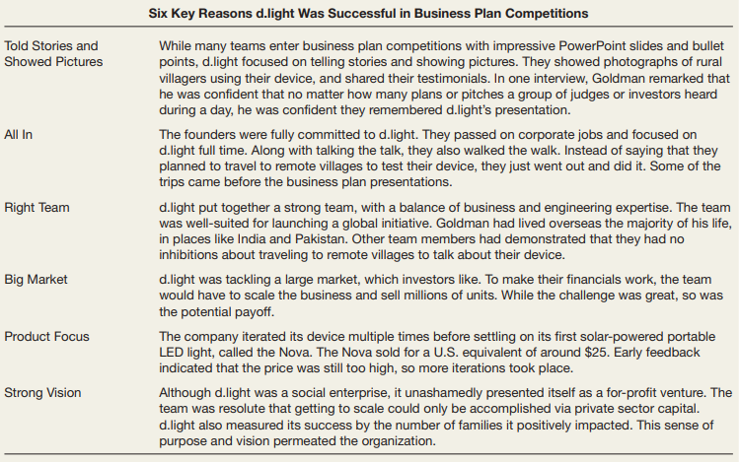for the future.

**d.light today**

Today, d.light is fully up-and-running. In 2008, the company reached about 100,000 people in eight countries. Its numbers now exceed one million units sold in 37 countries, and d.light projects strong growth for the future. Its first product was the Nova, which was a solar powered portable LED light that sold for a U.S. equivalent of about $25.

It’s most popular device is now the Kiran, which at U.S. equivalent $10 has been touted as the world’s most affordable portable solar light. It has a life of 50,000 hours, and if used to replace kerosene, can pay for itself in just four months. In one study in rural India, having a Kiran LED light in the home increased the study time for school-aged children two to three hours per day. d.light continues to strength its distribution strategy.

One strategy that has worked well is to employ “rural entrepreneurs” to sell the product. d.light likes to employ indigenous personnel, who know the local customs, people, and language, to sell its product on a commission basis. In India, d.light has established partnerships with NGOs and microfinance organizations. It has also scored $6 million in investment capital from U.S. and Indian investors.

**Challenges Ahead**

As it continues to grow, d.light faces a host of challenges. The primary challenge, as it continues to enter new areas, is to convince hesitant customers with little extra income to invest in unfamiliar technology. Although kerosene has many harmful side effects, it is an integral part of many villagers’ lives.

Another challenge is managing the tension between growth and profitability. d.light can actually accelerate profitability by slowing growth. Yet slowing growth is counter to its overall mission of reaching as many people as possible.

Finally, while d.light’s most basic lantern costs $10, the price will have to fall below $5 to make it universally affordable, according to a study by the International Finance Corporation, an arm of the World Bank. d.light has not yet reached this milestone.

**Application Questions**

1. Make a list of the ways in which Sam Goldman’s passions and life experiences made him the ideal founder for d.light. Then, make a list of your most distinct passions and life experiences. Study the list. Is there a potential venture for which you might be the most ideal founder? (MARKS 2.5 – CLO 1)

2. Find an example of an entrepreneurial company that is addressing a significant issue in the developing world. Briefly relate that company’s story. What similarities, if any, do you see between the company you’re reporting on and d.light?

(MARKS 2.5 – CLO 1)

**Q No 1.** Your friend Lisa Ryan is opening a smoothie shop that will sell a variety of smoothie drinks in the $4 to $5 price range. When you ask her if she is worried that the steep price of smoothies might prompt potential customers to buy a soda or a sports drink instead of a smoothie, Lisa answers,

*“You’re right. Someone could substitute a soda or a sports drink for a smoothie and save a lot of money. Is there anything I can do to discourage that?”*

What do you tell her? (01 MARK – CLO 01)

**Q NO 2.** Kelly Myers, a friend of yours, just told you an interesting story. She was at her parents’ house over the weekend and her father saw this book lying next to her backpack. He pickup it up and read Chapter 3. That is Feasibility Analysis. He told Kelly, “When you were growing up, I started and sold three successful businesses and never completed a feasibility analysis once. I wonder what the authors of your entrepreneurship book would say about that.” If you could advise Kelly about how to respond to her father, what would you tell her to say?

(02 MARKS – CLO 02)

**Q NO 3.** Marshall Hanson, the founder of Santa Fe Hitching Rail, a chain of nine steak restaurants in New Mexico, is considering expanding his menu, which is currently restricted to steak, hamburger, potatoes, and fries. He has just read a book about entrepreneurship and learned that entrepreneurs should study social trends to help identify new product opportunities. List the social trends that might help Marshall choose items to add to his menu. Given the trends you list, what items do you suggest Marshall add? (02 MARKS – CLO 02)